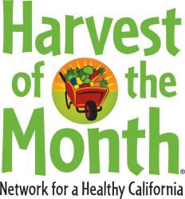 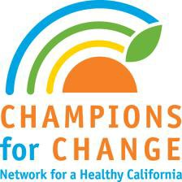

Book List 2012/2013 - Harvest of the Month Storybooks

These books were picked from the Network approved materials list.

|  |  |  |  |  |
| --- | --- | --- | --- | --- |
| **Month** | **HOTM** | **Storybook** | **Author** | **Accelerated Reader** |
| **SEP** | Apples | *The Seasons of Arnold’s Apple Tree* | *Gail Gibbons* | **YES** |
| *Our Apple Tree* | *Gorel Kristina Naslaud* | **YES** |
| **OCT** | Winter Squash/ Pumpkins | *Pumpkin Soup* | *Helen Cooper* | **YES** |
| *American Indian Foods* | *Jay Miller* | **YES** |
| *Seedfolks* | *Paul Fleischman* | **YES** |
| **NOV** | Persimmons | *Harvest Year* | *Cris Peterson* | **YES** |
| *The Enchanted Tree* | *Donna Heller, James Payne* | **NO** |
| **DEC** | Beets | *Plant Plumbing: A Book about Roots and Stems* | *Susan Blackaby* | **YES** |
| *The Science Chef* | *Joan D'Amico* | **NO** |
| **JAN** | Citrus | *Incredible Edible Science* | *Plaster & Krustchinsky* | **YES** |
| **FEB** | Dry Beans | *Yum! MmMm! Que Rico!* | *Pat Mora* | **YES** |
| **MAR** | Peas | *Pick, Pull, Snap!* | *Lola M. Schaefer* | **NO** |
| **APR** | Cucumbers | *And the Good Brown Earth* | *Kathy Henderson* | **YES** |
| *Gardening Wizardry for Kids* | *Patricia Kite* | **NO** |
| **MAY** | Strawberries | *You Are Healthy* | *Todd Snow* | **NO** |
| *Berries, Nuts, and Seeds* | *Diane L. Burns* | **YES** |
| **JUN** | Grapes | *The Grapes Grow Sweet* | *Lynne Tuft* | **NO** |
| **JUL** | Peppers | *Eddie’s Garden and How to Make Things Grow* | *Sarah Garland* | **YES** |

For important nutrition information, visit [www.cachampionsforchange.net.](http://www.cachampionsforchange.net/) For food stamp information, call 877-847-3663. Funded by the USDA Supplemental Nutrition Assistance Program, an equal opportunity provider and employer. ▪California Department of Public Health